Customer Churn Analysis & Retention Strategy for a Telecom Subscription Company
Introduction
Customer churn is a major challenge for subscription-based businesses, as retaining existing customers is often more cost-effective than acquiring new ones. In this project, I analyse customer data from a telecom subscription service to understand the key factors that lead to customer churn. Using data analysis techniques, I explore how contract type, pricing, tenure, and service usage influence customer retention. The goal of this project is to derive actionable insights and propose data-driven strategies that can help reduce churn and improve customer loyalty.
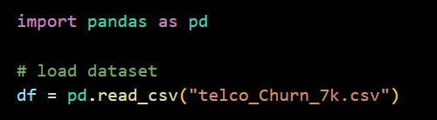
Step 1: Data Cleaning
Inspecting missing data
Before performing any analysis, it is important to check for missing or incomplete values in the dataset, as they can affect the accuracy and reliability of the results. Missing data may indicate data collection issues or inconsistencies that need to be addressed during preprocessing. In this step, I examine each column to identify the presence and extent of missing values. This helps in deciding whether values should be cleaned, converted, or handled using appropriate techniques before moving forward with analysis.
Questions 1.1: Which columns in the dataset have missing values, and what percentage of data is missing in each column?

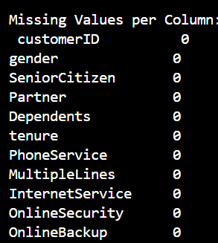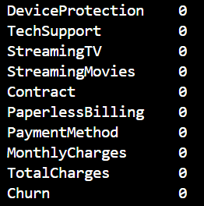
Finding: NO missing data was found in any of the columns.

Data types
Checking data types is a crucial step to ensure that each column is stored in the correct format for analysis. Sometimes, numerical columns may be incorrectly stored as text due to missing values or formatting issues, which can lead to errors in calculations and visualizations. By inspecting data types, we can identify such discrepancies early and decide whether type conversion or cleaning is required. This step ensures that subsequent analysis and modelling are accurate and reliable.
Question 1.2: Are there any inconsistencies in the data types across columns (e.g., numerical data stored as strings)?
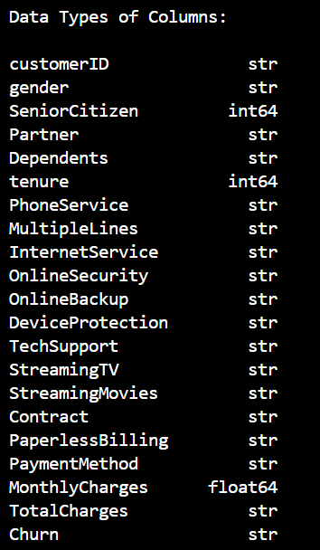
Finding: NO inconsistencies with the data types of the given data.
Step 2: Exploratory Data Analysis (EDA)
Churn count
Churn count provides a clear overview of the number of customers leaving the service. It serves as a baseline metric for understanding the severity of customer attrition and helps contextualize further analysis of churn across different customer segments.
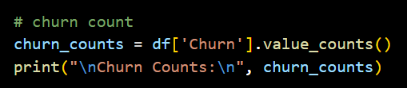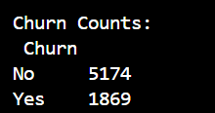
Understanding: 1869 customers of the 7043 customers churned (cancelled the subscription) and 5174 customers stayed with the same telecom company.
Churn percentage
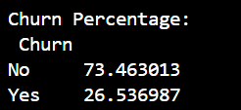
Understanding: 26.53% of the customers churned (cancelled the subscription) whereas 73.46% stayed with the same telecom subscription.

Churn vs Gender
Analysing churn based on gender helps determine whether there are any significant differences in retention between male and female customers. This analysis can reveal whether specific customer groups are more likely to leave the service. Understanding such patterns helps the company ensure that its plans, pricing, and services are equally effective across different customer segments. It also supports more inclusive and targeted customer retention strategies.

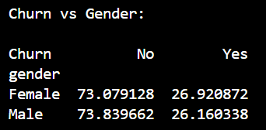
Understanding: The churn rates for male and female customers are very similar, with both groups showing nearly equal percentages of customers leaving the service. Female customers have a churn rate of about 26.9%, while male customers have a churn rate of about 26.2%. This indicates that gender does not have a significant impact on customer churn in this dataset.

Churn vs Senior Citizens
Analysing churn based on senior citizen status helps understand whether age-related factors influence customer retention. Senior citizens may have different service needs, pricing sensitivity, or usage patterns compared to younger customers. This analysis helps identify whether older customers are at a higher or lower risk of churn. Such insights can guide the company in designing targeted plans and support services for specific age groups.
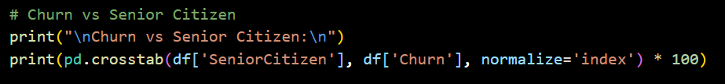
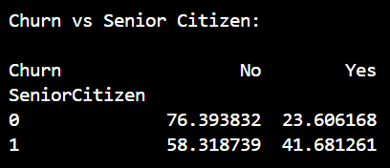
Understanding: The analysis shows that senior citizens have a noticeably higher churn rate compared to non-senior customers. Approximately 41.7% of senior citizens have churned, while only about 23.6% of non-senior customers have left the service. This indicates that senior customers are more likely to discontinue the service. The higher churn among senior citizens may be due to factors such as pricing sensitivity, service complexity, or lack of targeted support, suggesting the need for more senior-friendly plans and assistance.

Churn vs Partner
Analysing churn based on partner status helps understand how household or relationship factors influence customer retention. Customers with partners may have more stable living situations and may rely more on bundled or long-term services, which can reduce the likelihood of churn. This analysis helps identify whether single customers are more prone to leaving the service.

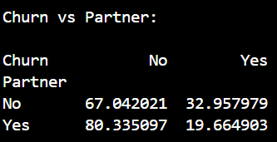
Understanding: The analysis shows a clear difference in churn rates based on partner status. Customers without a partner have a significantly higher churn rate of about 33%, compared to only around 19.7% for customers with a partner. This suggests that customers with partners are more likely to stay with the service, possibly due to more stable household needs or shared service usage.

Churn vs Dependent
Analysing churn based on dependent status helps understand how family responsibilities influence customer retention. Customers with dependents may rely more on stable and long-term services, making them less likely to switch providers. In contrast, customers without dependents may have more flexibility and may be more likely to churn.

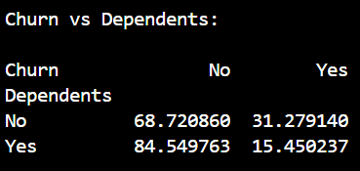
Understanding: The analysis shows a clear difference in churn rates based on dependent status. Customers without dependents have a higher churn rate of about 31.3%, while customers with dependents show a much lower churn rate of around 15.5%.

Churn vs Tenure
Analysing churn in relation to customer tenure is important because tenure reflects the length of time a customer has stayed with the service. Customers with shorter tenure are generally less loyal and more likely to discontinue the service compared to long-term customers. This analysis helps identify whether early-stage customers are at a higher risk of churn. Understanding this relationship allows companies to design targeted retention strategies for new and at-risk customers.

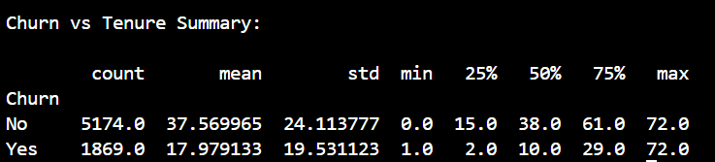
Understanding: Customers who churned had a significantly lower average tenure compared to those who stayed, indicating that churn is more common among newer customers. A large proportion of churn occurs within the first year of service, highlighting the importance of early-stage customer engagement and retention efforts.

Churn vs Contract Type
Analysing churn across different contract types is important because contract duration strongly influences customer commitment and retention. Customers on shorter or more flexible contracts tend to switch providers more easily, leading to higher churn rates. This analysis helps identify which contract plans are more stable and which require targeted retention strategies.
Contract types offered by the telecom service include:
- Month-to-month
- One-year contract
- Two-year contract
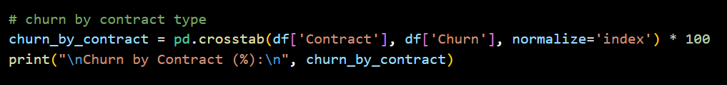
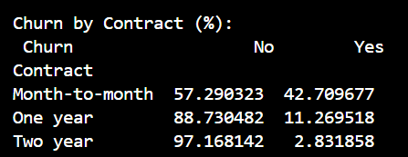
Understanding: the highest rate of churn was seen in the shortest contract (month-to-month) and the lowest rate of churn was seen in the longest contract (two year). We can see that shorter contract has a higher churning rate.

Churn vs Phone Service
Analysing churn based on phone service usage helps understand whether customers who use the company’s core calling service are more likely to stay. Customers who subscribe to phone services may be more engaged with the company and may rely on it for essential communication needs. In contrast, customers without phone service may only use limited offerings and could be more likely to switch providers.

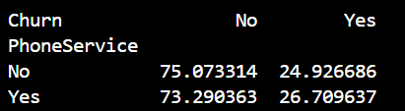
Understanding: The churn rates for customers with and without phone service are quite similar. Customers without phone service have a churn rate of about 24.9%, while those with phone service have a slightly higher churn rate of around 26.7%.

Churn vs Internet Service
Churn analysis based on internet service type helps the company understand which categories of customers are more likely to leave. Since internet service is usually a major part of a telecom customer’s bill and daily usage, differences in service quality, speed, reliability, and pricing can strongly influence customer satisfaction. The goal is to determine whether certain internet service types are associated with higher churn rates. If one category has significantly more churn than others, it indicates a possible problem in that segment—such as higher prices, poor service experience, or unmet customer expectations. This insight helps the company focus its marketing, pricing, and customer support strategies more effectively.
The dataset includes the following internet service categories:
- DSL (Digital Subscriber Line)
- Fiber Optic
- No Internet Service

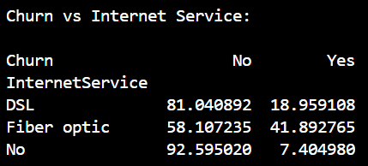
Understanding:
1. DSL
- 81.04% customers stayed.
- 18.96% customers churned.
- This shows moderate churn. Most DSL users remain, but a noticeable portion still leaves, possibly due to slower speeds or better alternatives.
2. Fiber Optic
- 58.11% customers stayed.
- 41.89% customers churned.
- This is the highest churn rate among all categories.
- Even though Fiber is high-speed, the higher price or customer expectations may lead to more dissatisfaction and churn.
3. No Internet Service
- 92.60% customers stayed.
- 7.40% customers churned.
- This group has the lowest churn rate.
- Customers using only basic services are less likely to leave because of lower costs and simpler needs.

Churn vs Online Service
Online services (such as online security or related internet features) are value-added services that increase customer engagement. Customers who subscribe to these services are usually more invested in the telecom provider. By analysing churn vs online services, we can understand whether these additional features help in retaining customers and reducing churn.

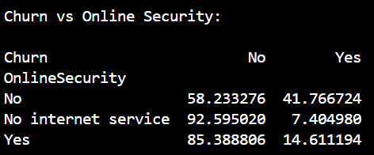
Understanding:
- Customers without online security have a high churn rate of about 41.77%, meaning a large portion of them leave the company.
- Customers with online security show a much lower churn rate of around 14.61%, indicating they are more likely to stay.
- Customers with no internet service have the lowest churn rate at about 7.40%.
- This shows that having online security is linked to better customer retention.
- Lack of security services may increase the chances of customers leaving the telecom company.

Churn vs Online Backup
Online backup is an additional service offered by the telecom company that allows customers to store copies of their data on secure remote servers. Analyzing churn with respect to online backup helps us understand whether customers who use this service are more likely to stay with the company.

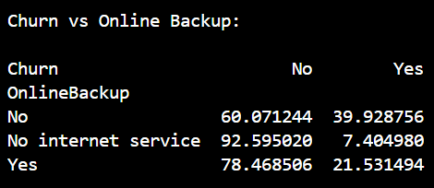
Understanding: Customers who do not have online backup show a much higher churn rate (around 40%) compared to those who have online backup, where churn drops to about 21%. This suggests that customers using additional value-added services like online backup are more likely to stay with the company. It indicates that bundled services increase customer stickiness and satisfaction.

Churn vs Device Protection
Device protection is a value-added service that covers repair or replacement costs in case a customer’s device is damaged or malfunctions. Analyzing churn with respect to device protection helps us understand whether customers who opt for this service are more likely to stay with the company.

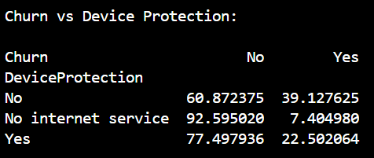
Understanding: Customers who do not have device protection show a churn rate of approximately 39.13%, which is relatively high. In contrast, customers who have device protection show a lower churn rate of about 22.50%, indicating better customer retention among those subscribed to this service. Customers with no internet service have the lowest churn rate at approximately 7.40%, as this feature is not applicable to them.

Churn vs Tech Support
This analysis helps us understand whether having technical support affects a customer’s likelihood to leave the telecom company. Tech support improves customer experience by solving connectivity or device issues quickly. If customers feel supported, they are usually less frustrated and more likely to stay. So this variable is important for identifying service-based churn drivers.

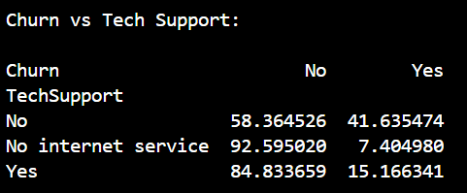
Understanding: Customers who do not have tech support show a high churn rate of approximately 41.64%, indicating that a significant portion of them leave the company. In contrast, customers who have tech support show a much lower churn rate of about 15.17%, meaning they are more likely to remain with the company. Customers with no internet service have the lowest churn rate at around 7.40%, as tech support is not applicable to them.

Churn vs Streaming TV
This analysis helps us understand whether having a streaming TV service influences a customer’s decision to stay or leave the telecom company. Streaming services are value-added features that increase entertainment options for customers. If customers actively use such services, they may feel more satisfied and become less likely to churn.
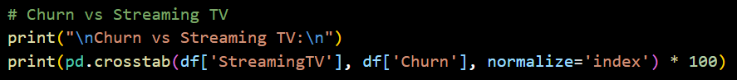
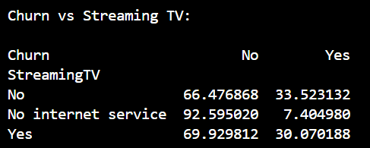
Understanding: Customers who do not have Streaming TV show a churn rate of about 33.52%, which is relatively high. Customers who have Streaming TV show a slightly lower churn rate of around 30.07%, indicating that the presence of this service does not significantly reduce churn. Customers with no internet service have the lowest churn rate at approximately 7.40%, since streaming is not applicable to them.

Churn vs Streaming Movies
This analysis helps understand whether customers who subscribe to the Streaming Movies service are more or less likely to leave the company. It shows how value-added entertainment services influence customer retention. If customers with streaming movie services churn less, it means such services increase satisfaction and loyalty.

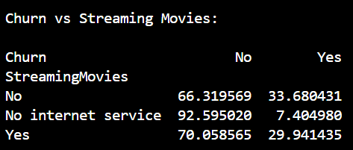
Understanding: Customers who do not have Streaming Movies show a churn rate of about 33.68%, which is relatively high. Customers who have Streaming Movies show a slightly lower churn rate of around 29.94%, indicating only a small reduction in churn. Customers with no internet service again have the lowest churn rate at approximately 7.40%, as streaming services are not relevant to them.

Churn vs Paperless Billing
This analysis helps us understand whether customers who use paperless billing behave differently from those who receive traditional paper bills. Billing methods often reflect customer preferences, age groups, and payment habits, which can influence churn.
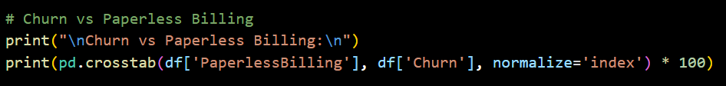
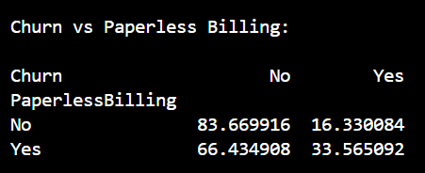
Understanding: Customers who do not use paperless billing show a churn rate of approximately 16.33%, which is relatively low. In contrast, customers who use paperless billing have a much higher churn rate of about 33.57%. This indicates that customers enrolled in paperless billing are more likely to leave the company compared to those receiving traditional paper bills. Overall, paperless billing appears to be associated with higher churn, suggesting that customers who prefer digital billing may be more flexible in switching providers or may belong to higher-risk customer segments.

Churn vs Payment Method
This analysis shows how different payment methods relate to customer churn. Payment behaviour often reflects customer convenience, trust, and engagement with the service. Understanding this helps the company promote payment options that improve retention.
Payment methods in the dataset:
- Electronic check
- Mailed check
- Bank transfer (automatic)
- Credit card (automatic)

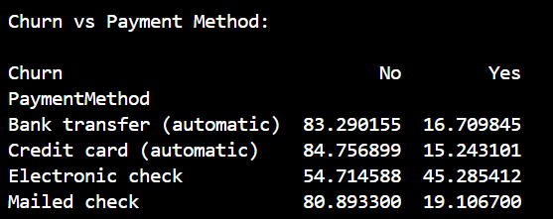
Understanding: Customers who pay through automatic methods such as bank transfer (16.71% churn) and credit card (15.24% churn) have the lowest churn rates, indicating stronger retention. Those using mailed checks show a slightly higher churn rate of about 19.11%, but still relatively stable. However, customers who pay via electronic check have a significantly higher churn rate of around 45.29%, making them the most likely group to leave.

Step 3: Business Insights
- Contract Behaviour Insight
The strongest churn driver is commitment level. Customers on month-to-month plans leave far more often than long-term customers. This tells us churn is not random — it’s a commitment problem, not just satisfaction.
Meaning: Many customers are not confident enough to stay long-term.

- Early-Life Customer Drop-Off
Most churn happens in the early tenure period. Customers who leave usually haven’t stayed long. Once they stay longer, they rarely leave.
Meaning: The first few months determine lifetime value. Customers decide whether they like the service very early.

- Service Adoption Insight
Customers without value-added services:
- No tech support
- No online security
- No backup
- No protection
→ churn much more.
Meaning: The more integrated the customer becomes, the harder it is for them to leave. Retention is strongly linked to ecosystem dependency, not just price.

- Pricing Perception Insight
Fiber users churn the most even though it is the best technology.
Meaning: Expectations > Experience. Customers paying more expect premium support. When they don’t feel premium treatment, they leave faster than budget users.

- Payment Behaviour Insight
Electronic check users churn massively compared to automatic payment users.
Meaning: Manual payers are “emotionally uncommitted customers” Autopay customers psychologically accept long-term usage.

- Household Stability Insight
Single customers, no partner, no dependents, senior citizens → churn more.
Meaning: Stable households value continuity, Independent individuals value flexibility

- Entertainment Services Insight
Streaming services barely reduce churn.
Meaning: Entertainment doesn’t build loyalty — support does. Customers stay for reliability, not fun features.

Step 4: Strategy Recommendations
- Early-Stage Retention Strategy
Problem: Customers decide to leave within first months
Actions
- 30-day onboarding call
- “Welcome kit” explaining services
- First-month satisfaction survey
- Dedicated onboarding support agent
- Free tech support for first 60 days

- Contract Conversion Strategy
Problem: Month-to-month users churn most
Actions
- Offer discount for switching to 1-year plan
- Give free upgrade for long contracts
- Loyalty points for tenure milestones
- Upgrade speed after 6 months commitment

- Service Bundling Strategy
Problem: Customers without add-ons churn more
Actions
- Bundle security + backup free for 3 months
- Default includes tech support in premium plans
- Show “Your protection score” in app
- Recommend services based on usage

- Payment Method Strategy
Problem: Electronic check users churn most
Actions
- Autopay cashback
- Discount for credit card billing
- Remove service fee for automatic payment
- Reward points for consistent billing cycles

- Premium Customer Experience Strategy
Problem: Fiber customers expect more
Actions
- Priority support for fiber users
- Faster issue resolution SLA
- Proactive outage alerts
- Personalized support line

- Senior Citizen Retention Strategy
Problem: Seniors churn higher
Actions
- Simplified plans
- Dedicated helpline
- Installation assistance
- Printed guides & training

- High-Risk Detection Strategy
Create churn risk flag:
High risk if:
- Month-to-month
- No tech support
- Electronic check
- Short tenure
Then:
- Trigger retention call
- Offer discount automatically

Step 5: Conclusion
Customer churn is driven primarily by lack of commitment, limited-service adoption, and weak early engagement rather than demographic differences. Customers who integrate deeper into the service ecosystem through long-term contracts, automatic payments, and support services show significantly higher retention. Therefore, the company should focus on early customer experience, service bundling, and behavioural commitment strategies instead of only pricing adjustments to reduce churn.

